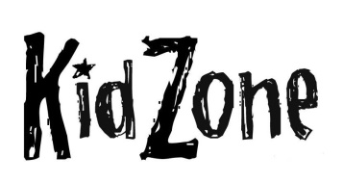
Thanks for joining us today in
Ridgecrest’s Elementary Ministry!
Tell us about yourself:

Date: __________ First Time Guest Out of Town Guest Returning Guest

Child’s Name: ___________________ DOB: _________ Boy Girl
Child’s Name: ___________________ DOB: _________ Boy Girl
Child’s Name: ___________________ DOB: _________ Boy Girl
Parent’s Name(s): _________________________________
Address: _______________________________________
City:__________________ State:______ Zip:____________
Phone: _____________________ E-Mail: ______________________________________
Guest of: ____________________________________ Are Snacks Ok? Yes No
Special Considerations/Allergies: ___________________________

Helping Families Build a Foundation of Faith…

Thanks for joining us today in
Ridgecrest’s Elementary Ministry!
Tell us about yourself:

Date: __________ First Time Guest Out of Town Guest Returning Guest

Child’s Name: ___________________ DOB: _________ Boy Girl
Child’s Name: ___________________ DOB: _________ Boy Girl
Child’s Name: ___________________ DOB: _________ Boy Girl
Parent’s Name(s): _________________________________
Address: _______________________________________
City:__________________ State:______ Zip:____________
Phone: _____________________ E-Mail: ______________________________________
Guest of: _____________________________________ Are Snacks Ok? Yes No
Special Considerations/Allergies: ___________________________

Helping Families Build a Foundation of Faith…

